Student’s name | …………………………………………………….…… | Grade | 4
Subject | Computer | Week No. | 2
Lesson Title | Computer Memory | Unit
Worksheet No. ( 2 ) (Answer)

Instruction: Match the following

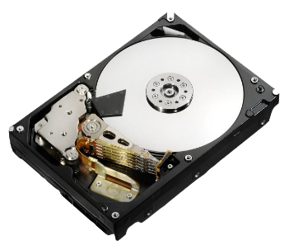 | CPU
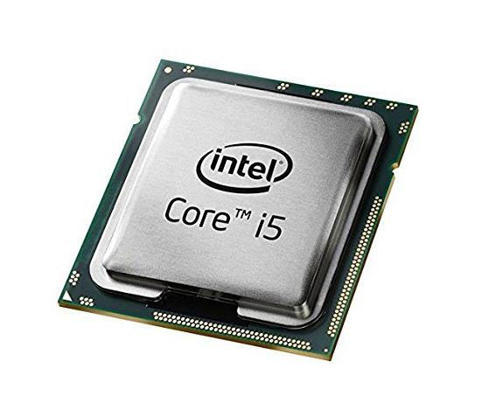 | Hard Disk
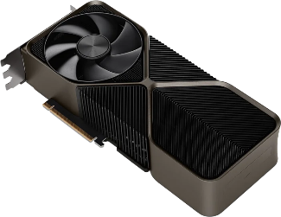 | RAM
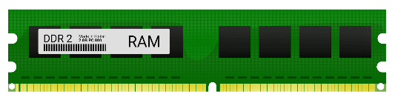 | GPU

Good Luck

